About the APP

**Made by :** Sailesh NS(19BCE2066)

**Software :** Android Studio

**Language :** Java

**App Name :** Monnaie Converter

**Description:**

I used the basic Empty Activity with API 28 Android 9.0 (PIE). The language was JAVA. I used a constrain layout to design the page. The main components are Text View, Edit Text, Button and Spinner. The app is for currency converter. Its capable of converting between 15 different countries. At first you need to enter the amount for conversion and then use the two spinners for selecting from and to currency and then click a button named “convert” to display the converted amount in text view.

**Features:**

* It runs in all android 9 and android 10 smartphones.
* The edit text accepts only numbers and a decimal point.
* At first the button will be Disabled you can’t click till you enter a valid number in the edit text.
* If you select both from and to in spinner as same currency, after clicking convert button you will get an error toast message.
* If you enter a zero for conversion it again shows an error toast message.
* Only if you enter a valid number and different currency in from and to spinner, you will get a text view/answer.
* The answer will also have the short form of the currency concatenated to the number, example you will get “75 INR”, ”20 USD”,..
* I have set a proper app logo and also background picture.

**Logo for the App:**



**Apk for the app:**



**Video Recording of the app:**



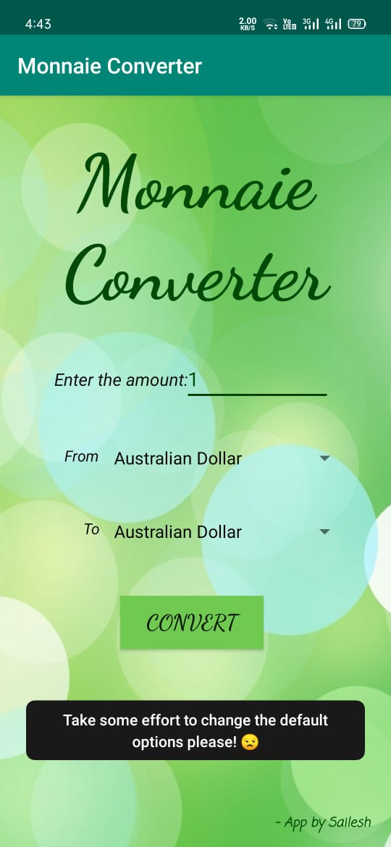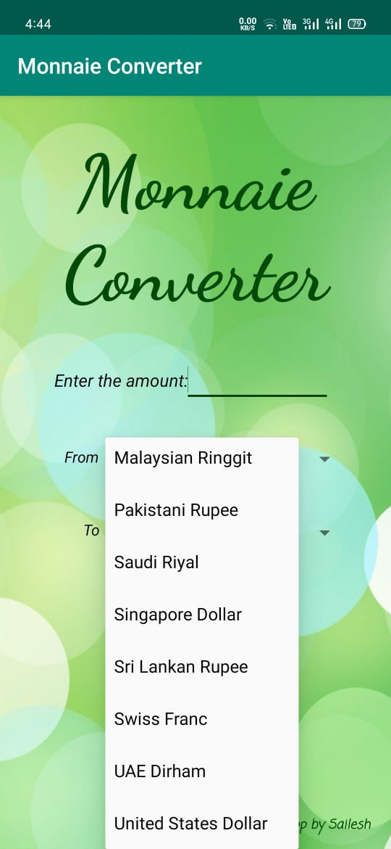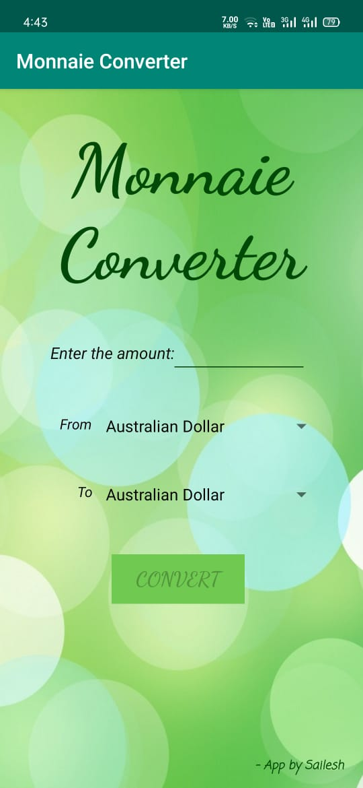**Screenshots of the App:**

